Git-Github

Version control system:

Problems when we don’t use version control system

If we save our code in local computer:hard disk crash

Computer problem- code lost

Multiple people has to contribute- cant

No tracking of versions

Version control system solves all these problems:

Code is saved on cloud -we don’t loose

Code saved in cloud sink to local system

* Multiple people can work
* Merging is easy
* We have all changed tracked
* Any changes will make in different versions
* GIT,MERCURI,SUB version

What is github:

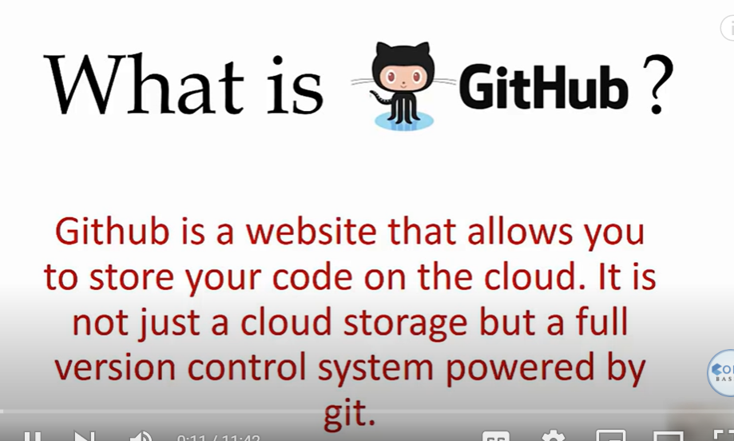

Create login

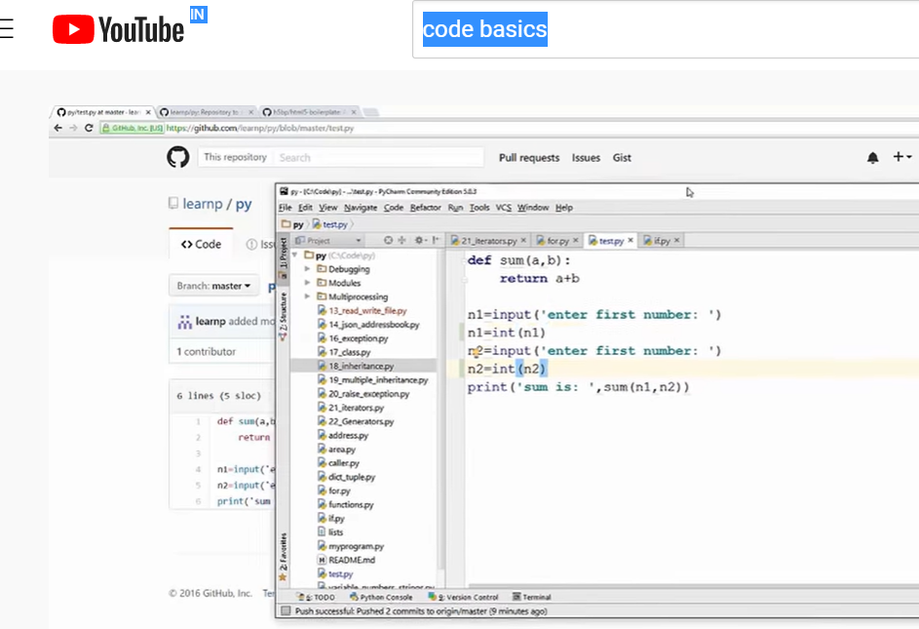

Put changes in github

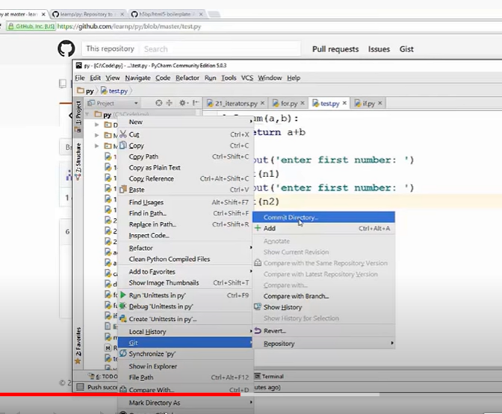

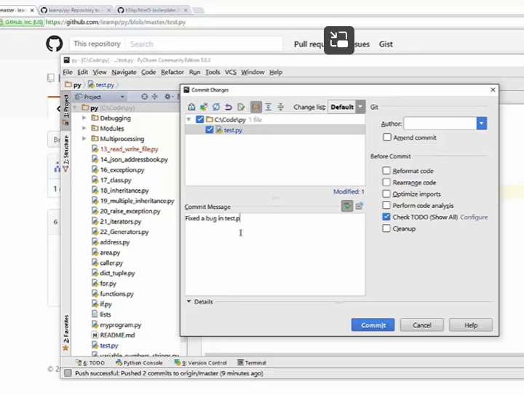

Features of git:

Pull request:

Allow you to collaborate with other projects’

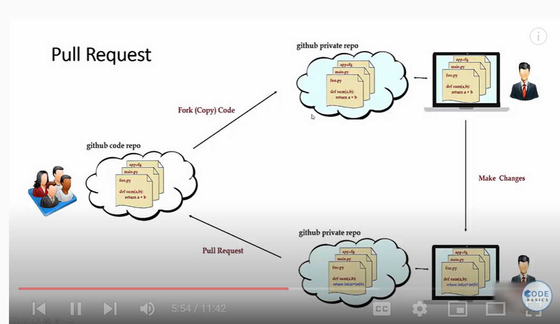

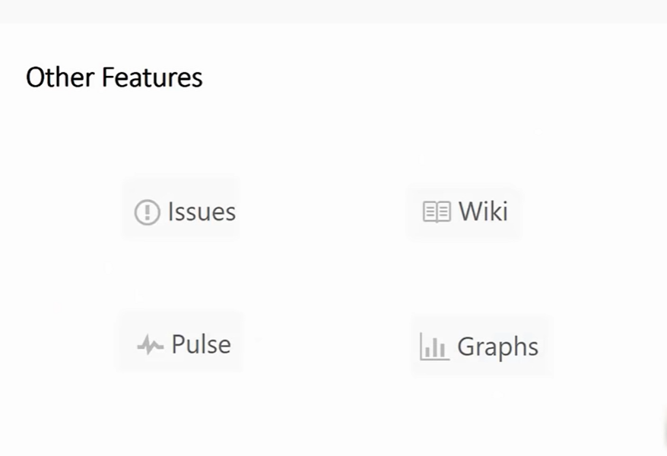

Issue tracking

Wiki: documentation

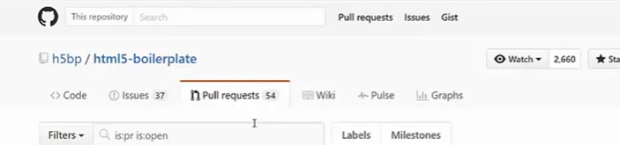

Pulse:

Whats going at present in ur projects

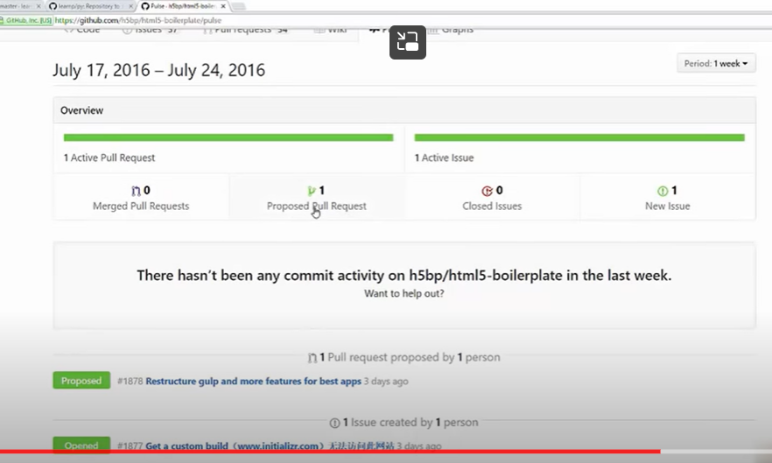

Graphs:

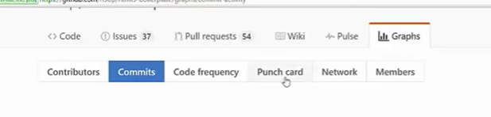

**How To Install Git**

Download git

Git.scm.com

Next-next-next

Gitbash

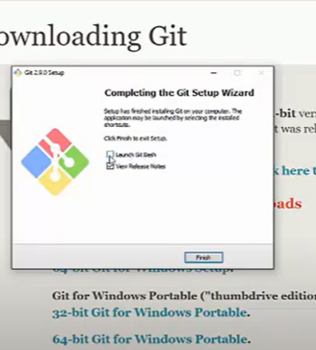

Open gitbash- give git command

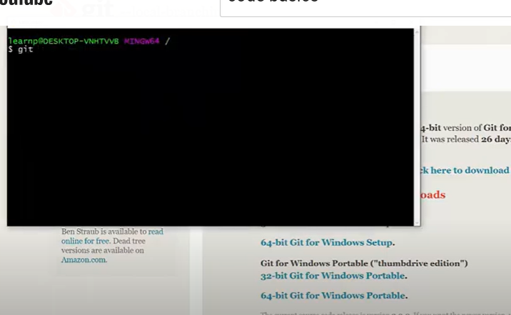

Or window cmd

Git

**Basic Commands: add, commit, push**

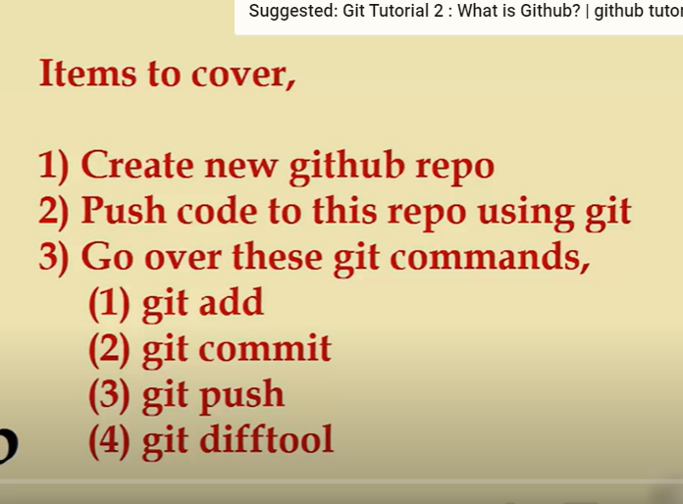

Login – goto new repo

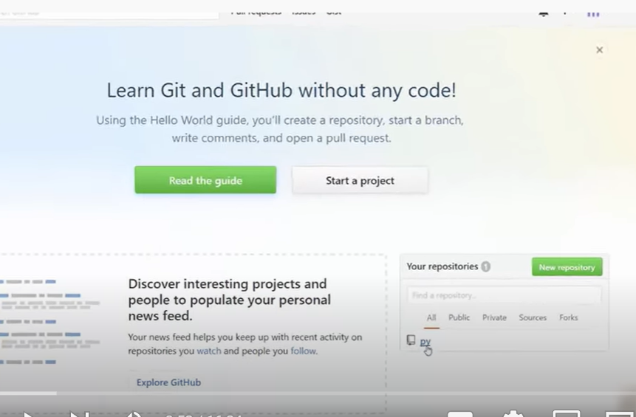

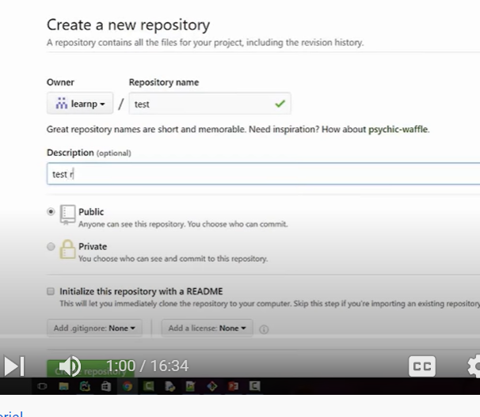

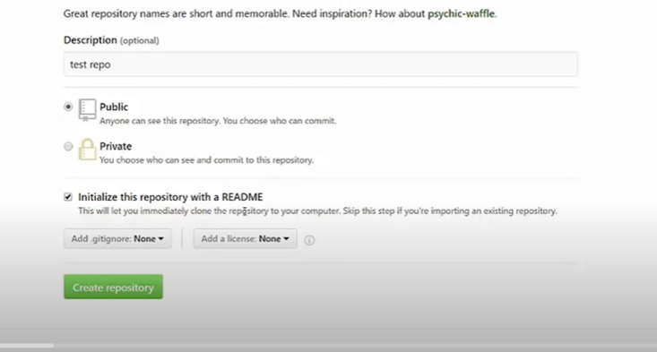

Read me file explain what the code is about

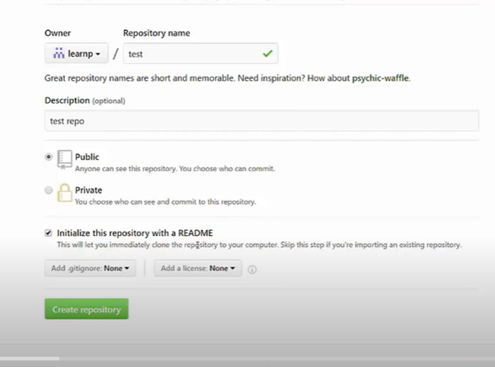

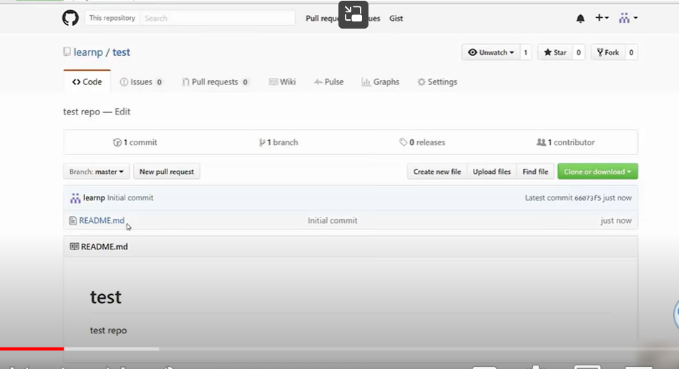

It create an empty repository in a read me

Click on read me

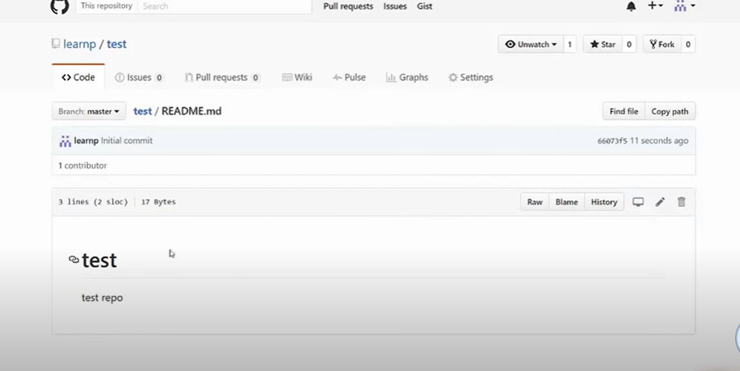

How can I connect this with local computer

Open gitbash

Now clone repository meaning copying repository from github to local compter

Open gitbash

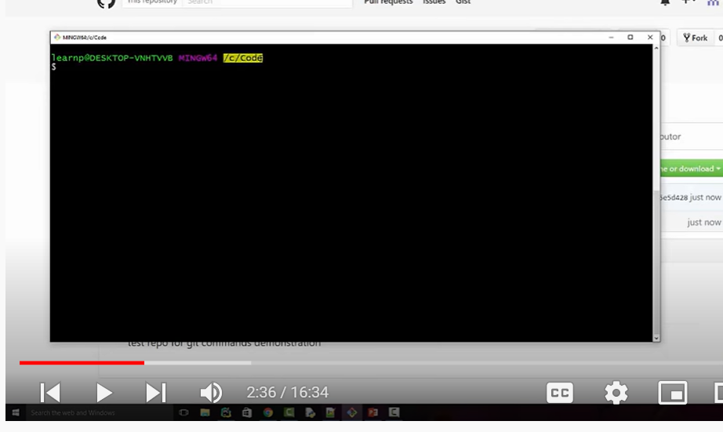

In github repository – copy the link/ url

] 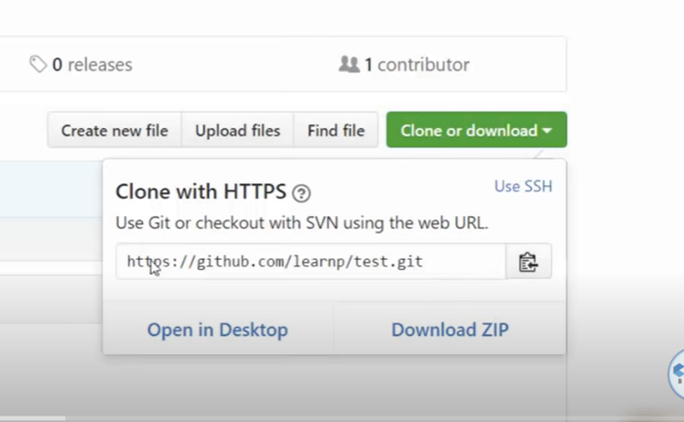

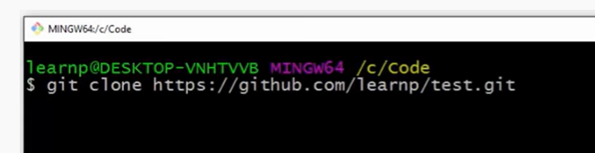

Enter

Ls

Testdirectory file

Go to that file

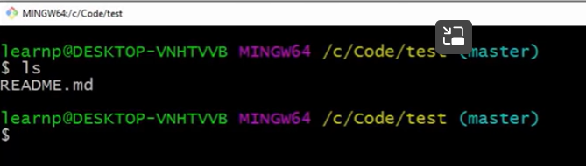

Git status – tells changes in a repository

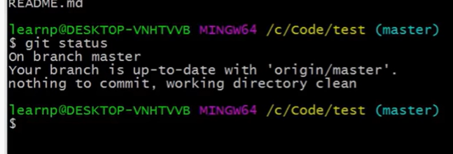

Now add first python file

Now go to pycham

Open new python file in test repo

Create A pogramme

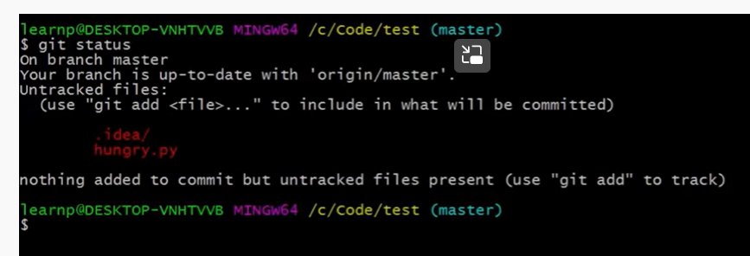

There are untracked file means files we need to commit

Now add hungry.py in git

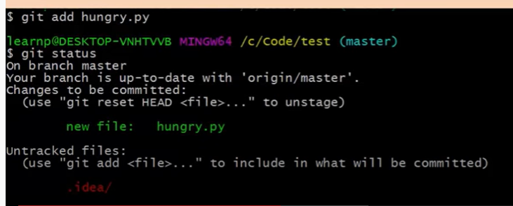

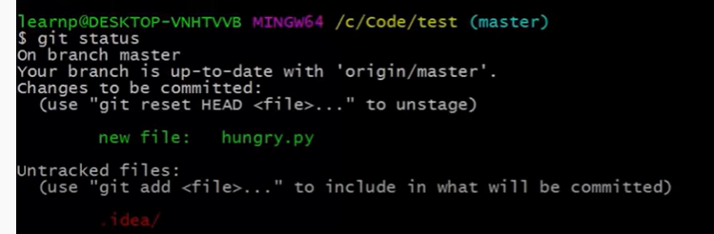

Now in git status

File in green colour – it means in staging area

Now git commit – it takes files from staging area to commit it locally



-m means message

Commited changes in local version control system

Git status

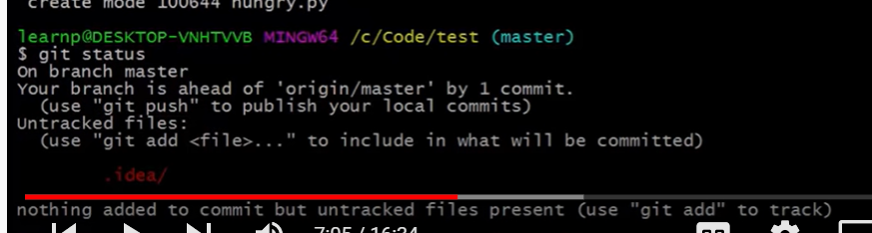

Git log

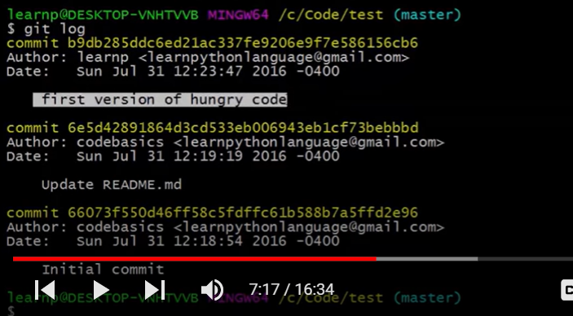

Git log shows all commit id

1, git add

2. git commit

3. git push

Git push add code to github

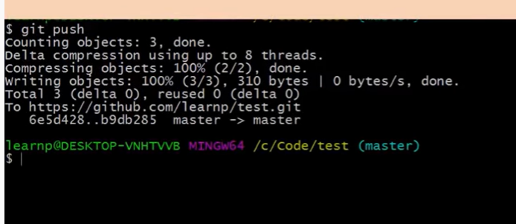

Now change code in same hyngery.py

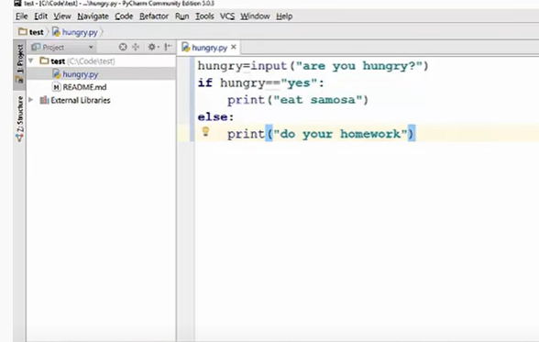

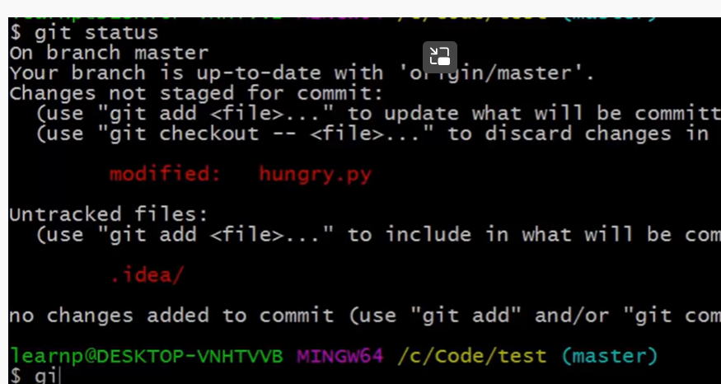

Now add to staging area

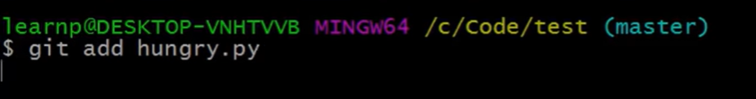

Git status

Now git difftool

To know the difference between previous and present code

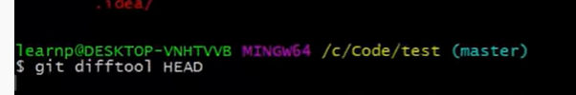

Open pycham with different codes

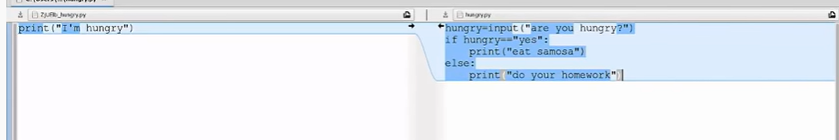

Now git commit along with message



Now push



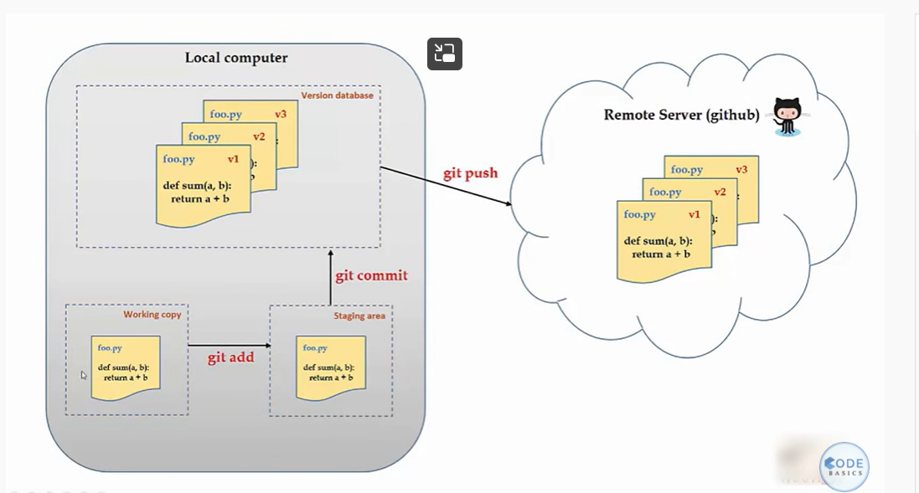

**Undoing/Reverting/Resetting code changes**

Clone the repository to local computer

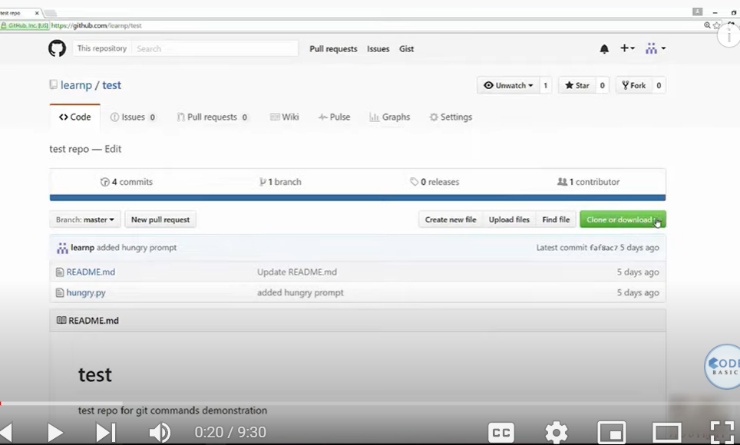

Copy url

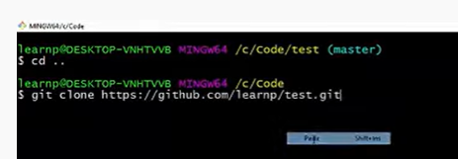

Open directory in pycham

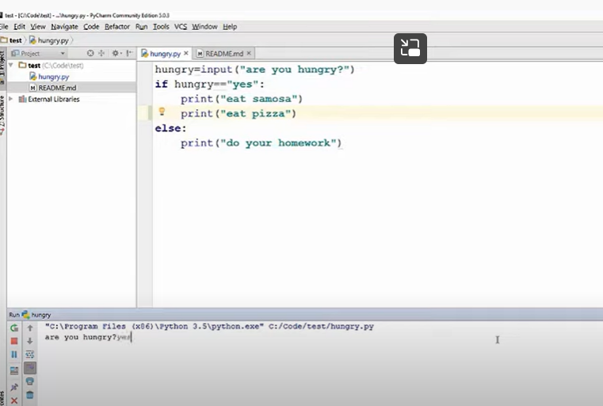

Added new line

Now I want to undo-------uncomited change

Goto that directory – location

Git status

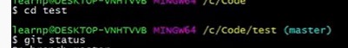

Undo changes

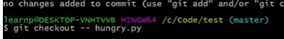

If we have multiple file changed both in readme and hunger.py

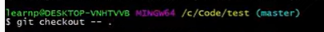

Use “.”

Undo – commited changes

Now do changes in file

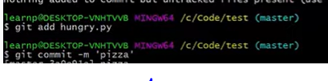

To know comits – git log

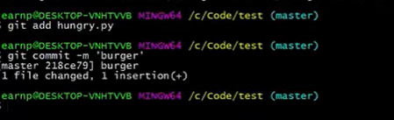

To undo commited code we need commited id

Git log -id

Copy id

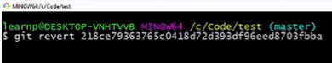

:q

Git log

Below code

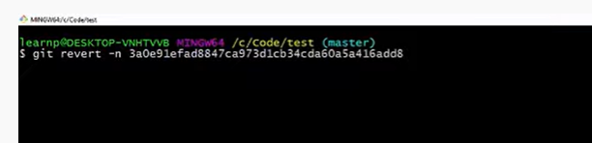

This will change code

But we need to explicitly comit change when I use -n

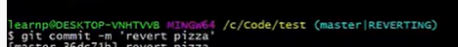

-n supplying not supplying

Not suplying commit changes automatically

-n need to commit

RESET: to rest undo things, take us to previous timestamp

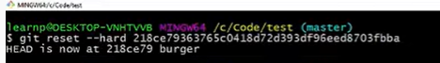

**Branches (Create, Merge, Delete a branch)**

To make or preserve orginal file

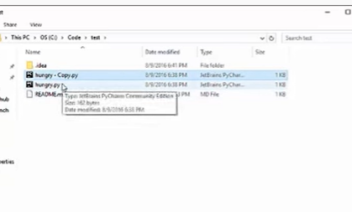

Copy pase the file

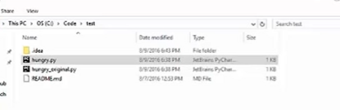

Make one as original file

That was manual

But git by deaful support branch concepts, it allows you to create branch with code

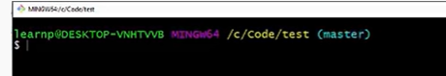

Master is a direct branch

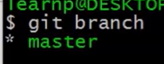

Create new branch

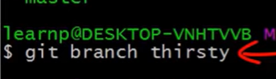

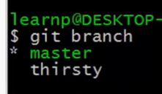

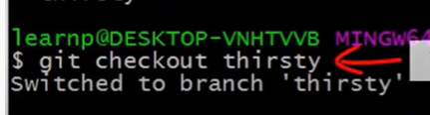

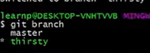

Star in front of thirsty – means active

Make changes in code

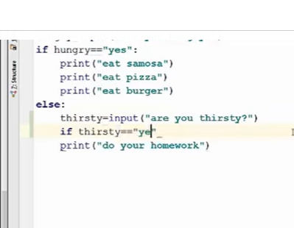

Git add

Git commit -m “water”

Now see in master branch

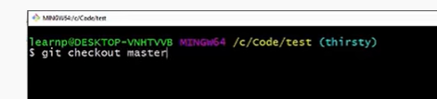

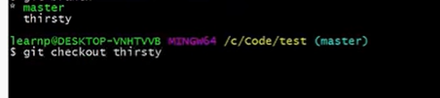

Merge two branches:

First we need to goto base branch where I want to combine

I wanted to merge thirsty branch in master branch

Go to master branch and merge with thirsty branch

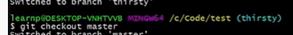

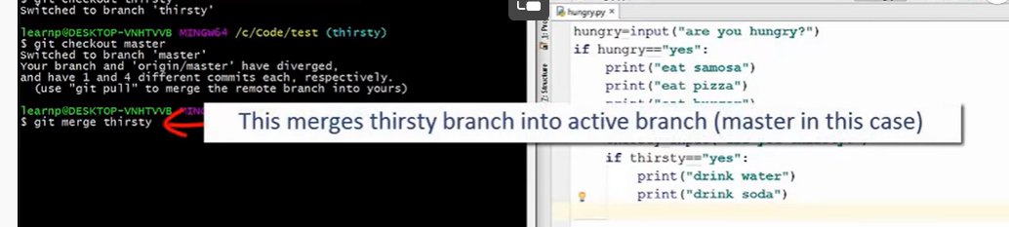

After this

:wq ( for comiting)

Git log

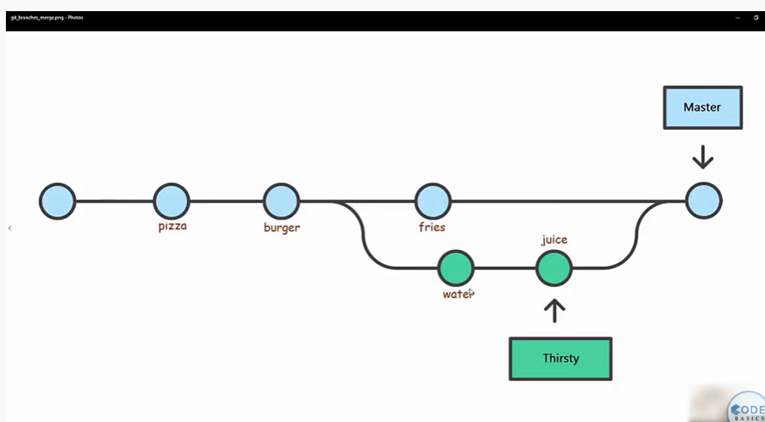

Now I github we have only master branch

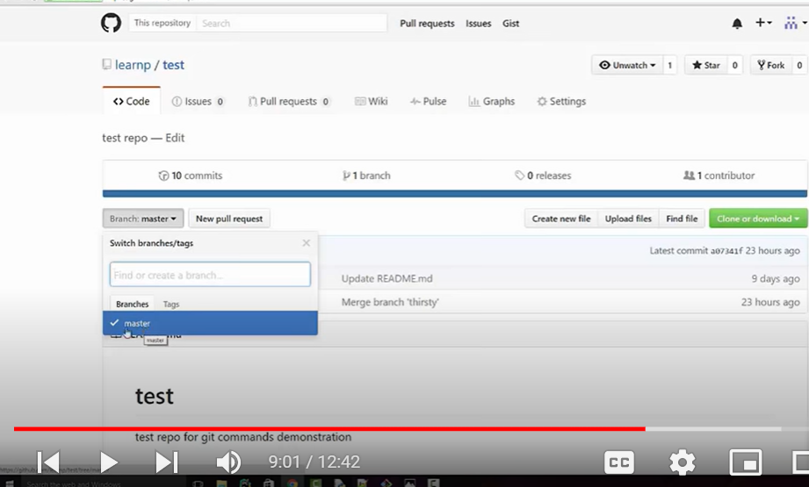

We need to post

Now push thirsty branch

If in gitbash if u are in master branch

If u use command git push – it push changes in master branch

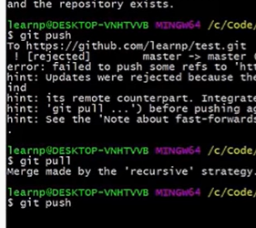

Now to push thirsty branch

Change to thirsty branch

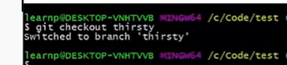

Now

Git push

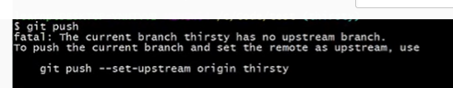

It says no upstream branch means no thirsty branch in github

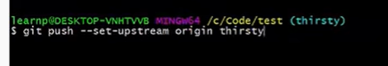ve

Now refresh github

See master and thirsty branch

DELETING BRANCH:

First create new dummy branch and activate

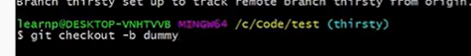

Above command created dummy branch and activated as well

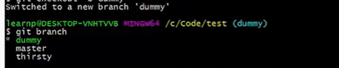

To delete brach

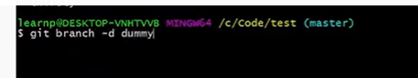

**What is HEAD?**

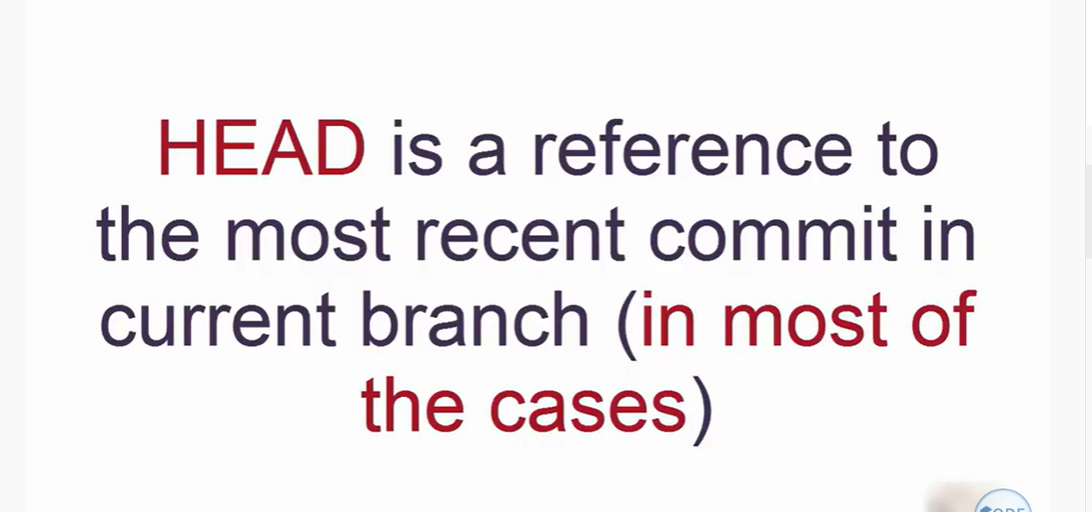

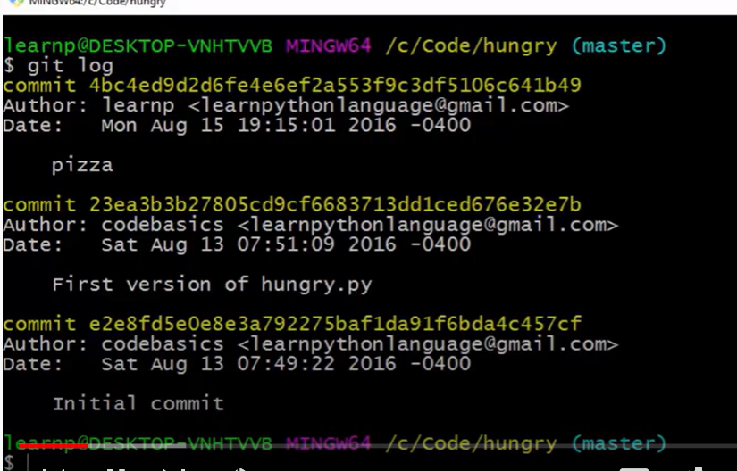

Git head is – pizza

To know head

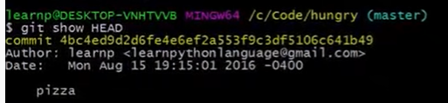

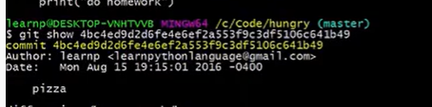

They both produces same output

Change code in hungry.py

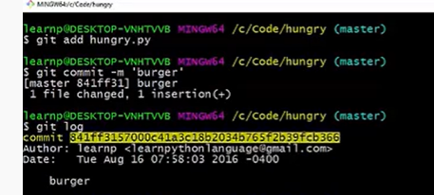

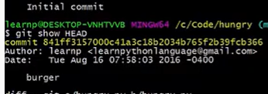

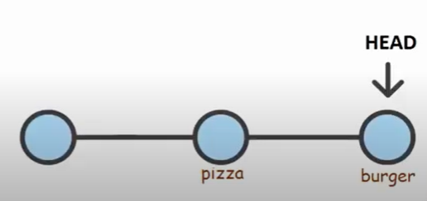

Another way of using HEAD

‘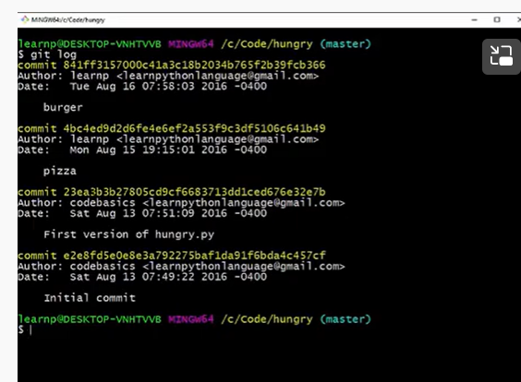

Difference between two comands

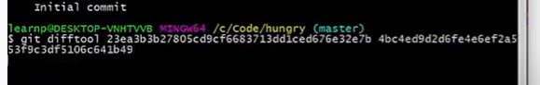

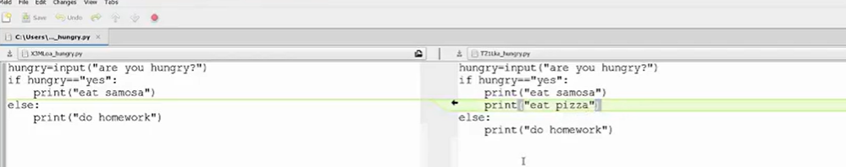

Same we can do by using head

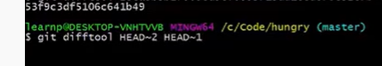

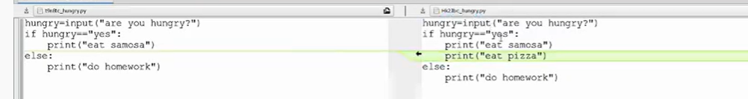

Same output

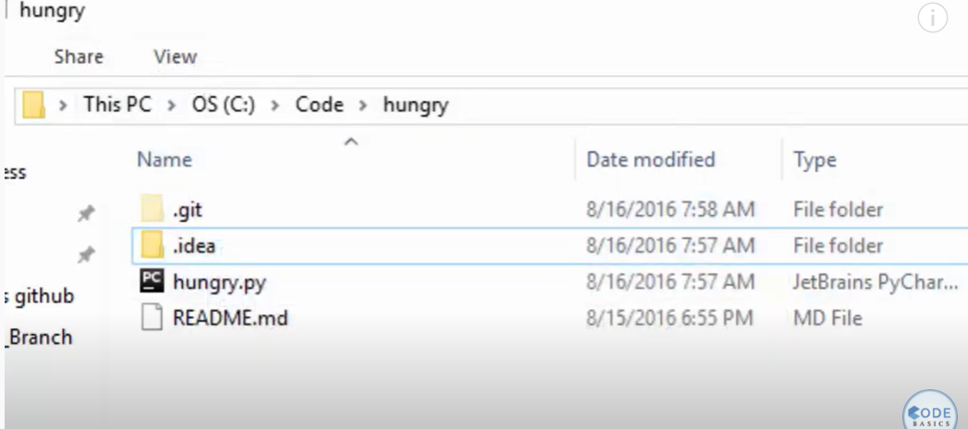

Open .git

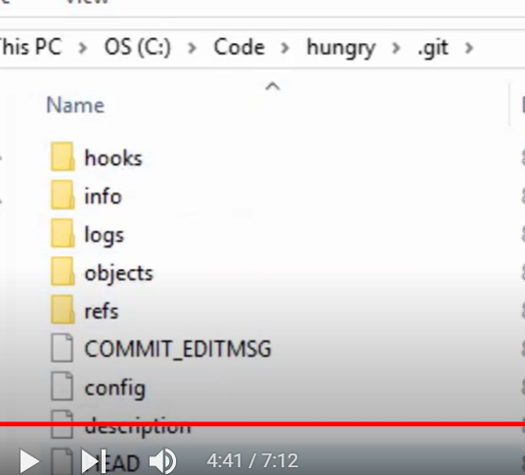

Head is one of file



When head doent refer to most recent comit ---- called “detached head”

Go to log

When u select comit id which is not recent and make some changed in that comit

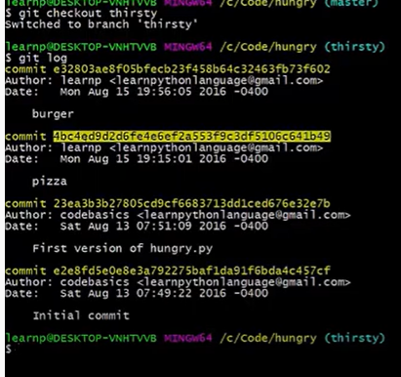

And enter

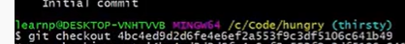

Give id number

It display

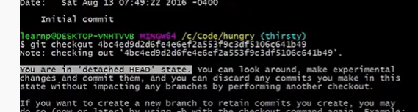

Detached head state which means it not into recent comit

Now in head file

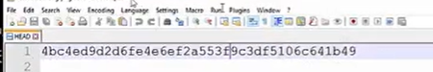

Now to come to master

Checkout master

**Git Tutorial 8 - .gitignore file**

We have git repository file

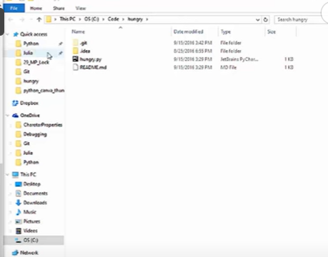

Git status

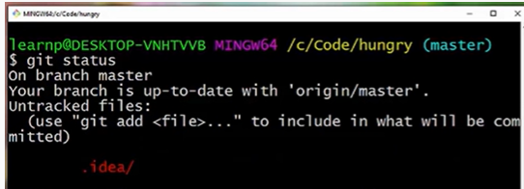

-idea file coming as untrack file

Create git ignore file

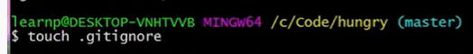

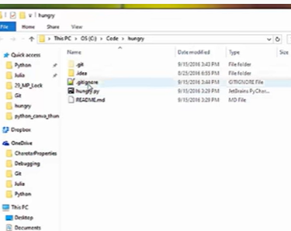

Open .ignore file

Write below .idea and save it

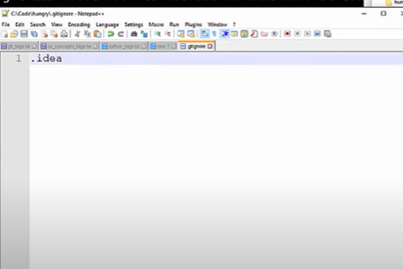

Git status

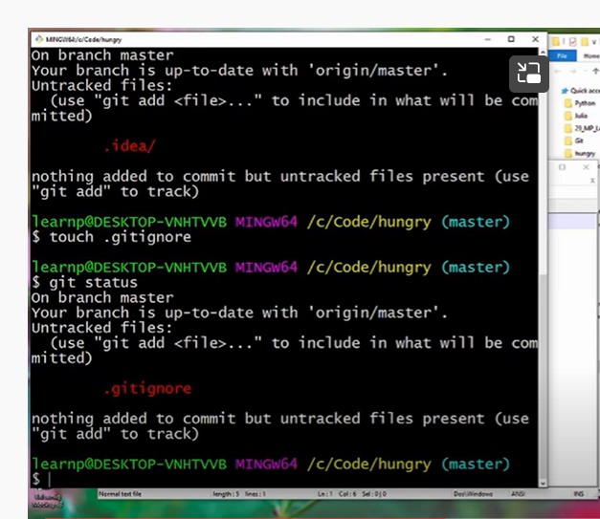

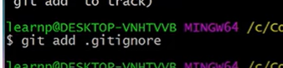

Sometimes a specific file which we want to ignore

Add that in gitignore file

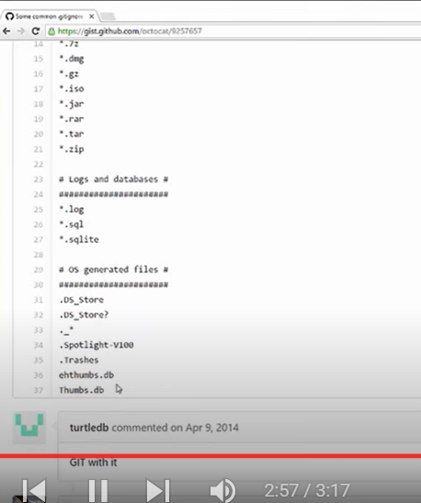

**Diff and Merge using meld**

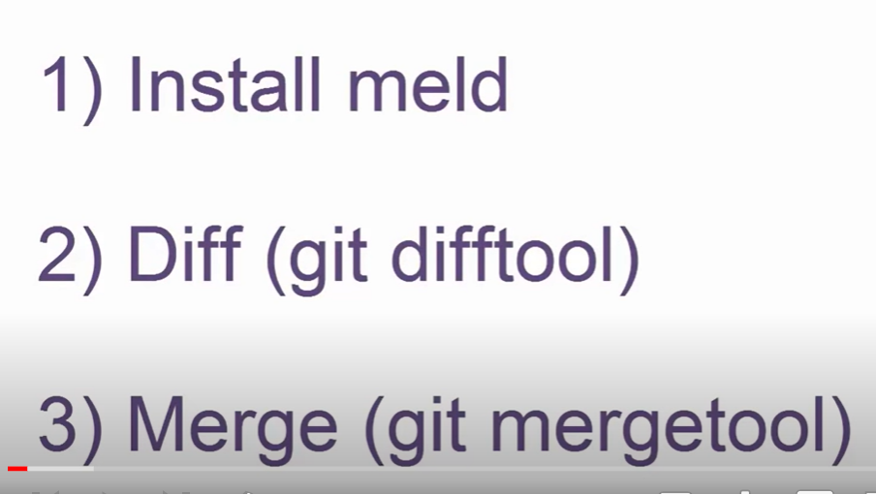

Download meld

Install

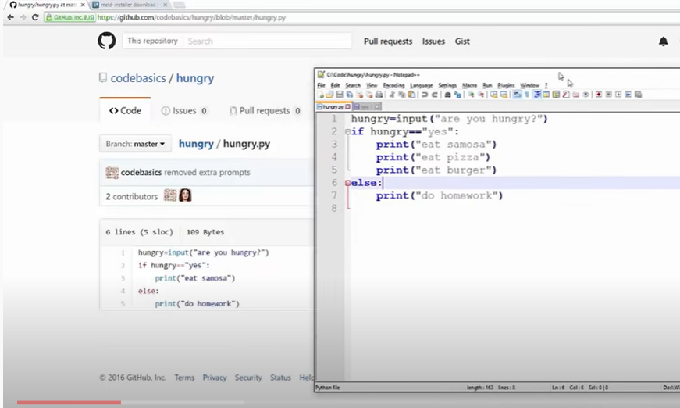

Added last two line

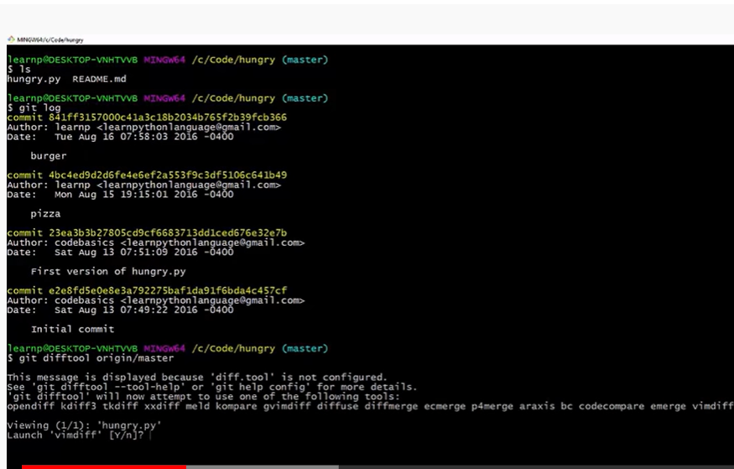

Y

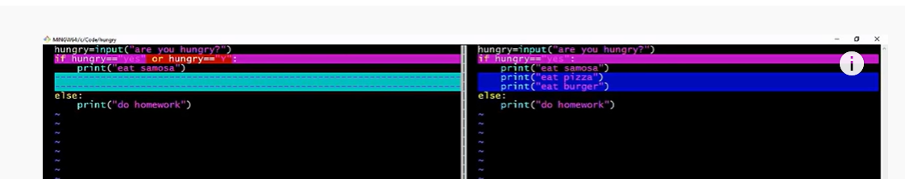

We need to use meld

First we need to configure it

Go to c users directory

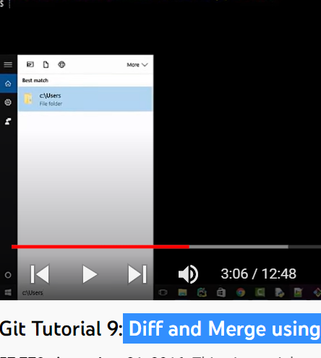

* Gitconfig file

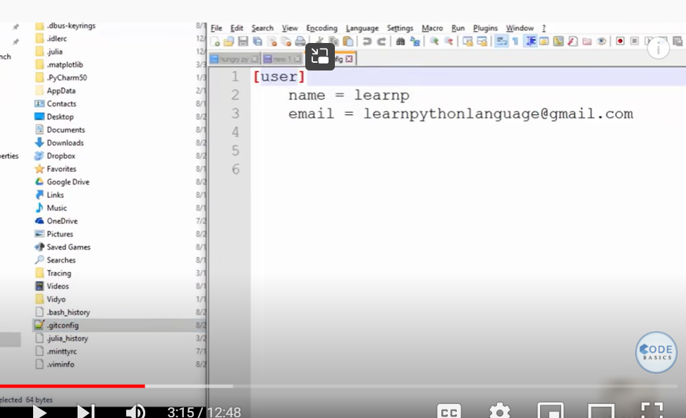

Add them

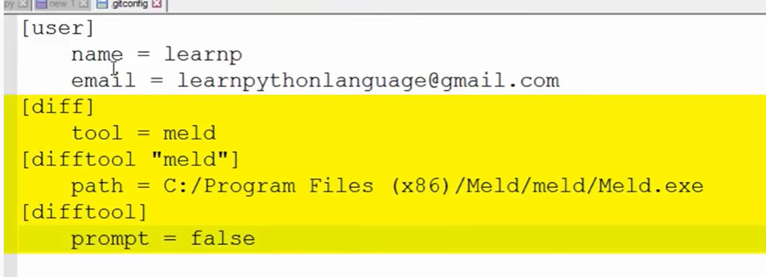

Nice looking ui

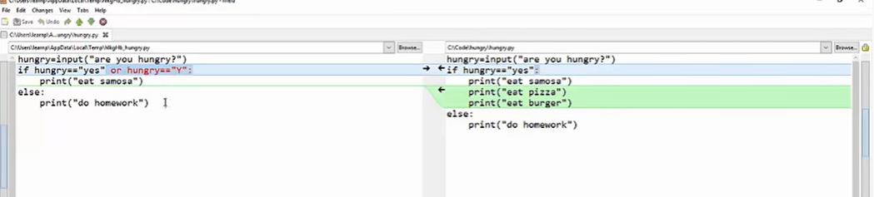

Local code in system

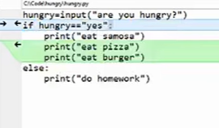

Code in git

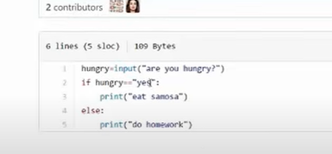

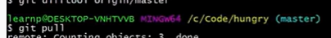

Now correct diff

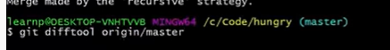

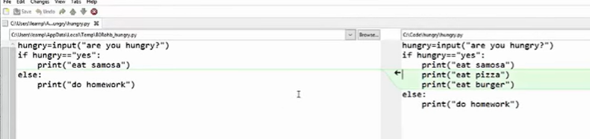

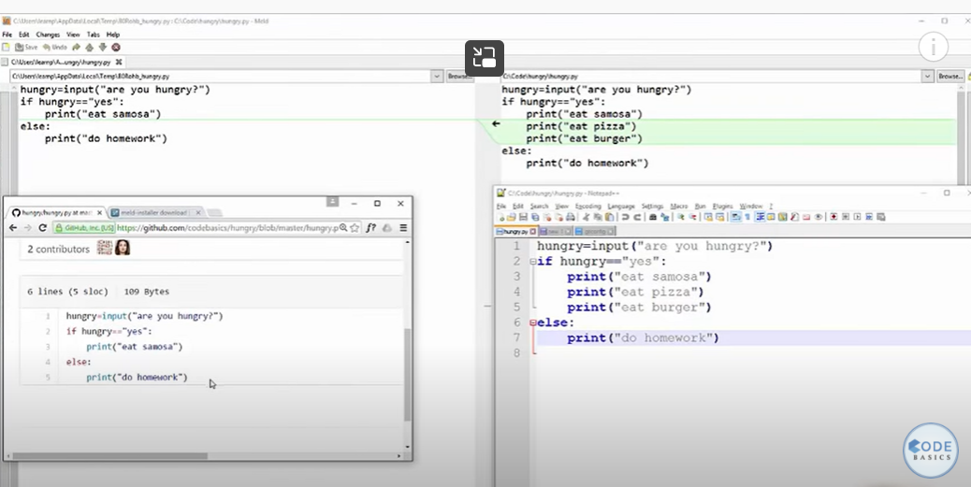

If u did changes and u didn’t comit

How to see

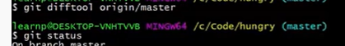

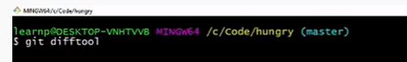

You can use different diff tools

Now add and commit changes

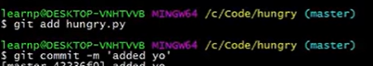

Then push

If someone added some code in github code- local repository and upstream got out of control

Now use

gIt pull

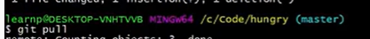

Now local file is messy

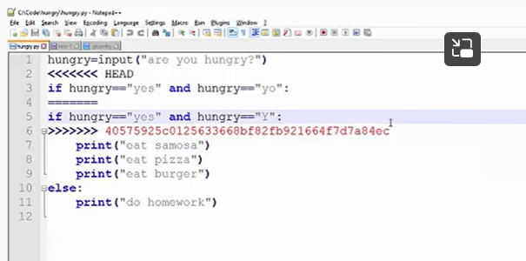

Head and upstream change

For example if u want to keep upstream change

Now u need to open merge too

Before thet u need to configure

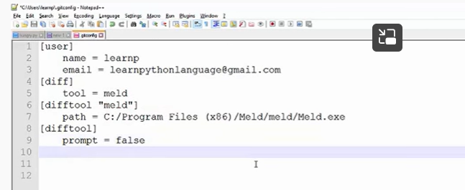

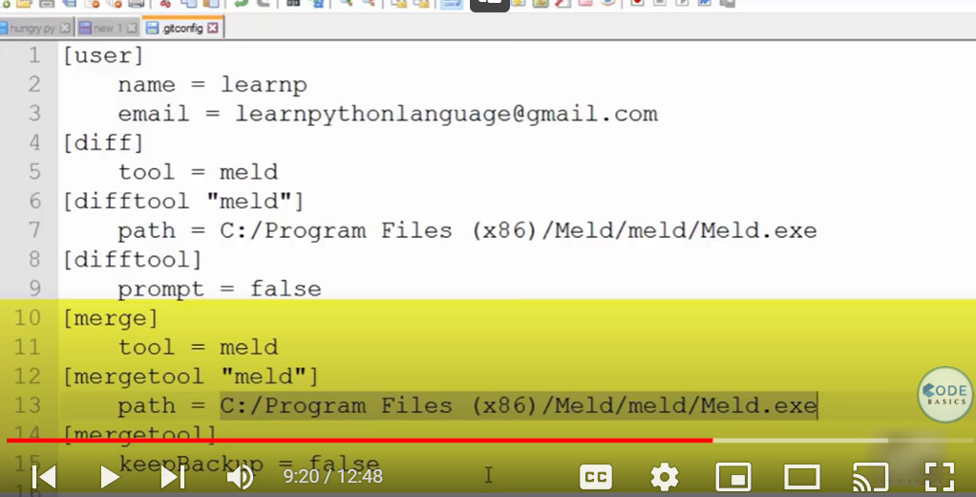



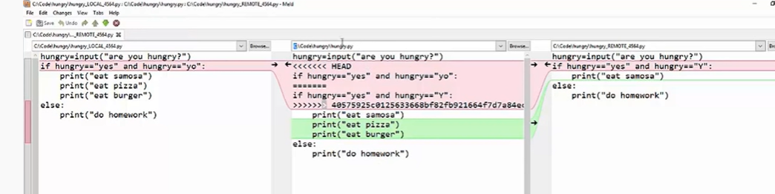

Middle -localfile

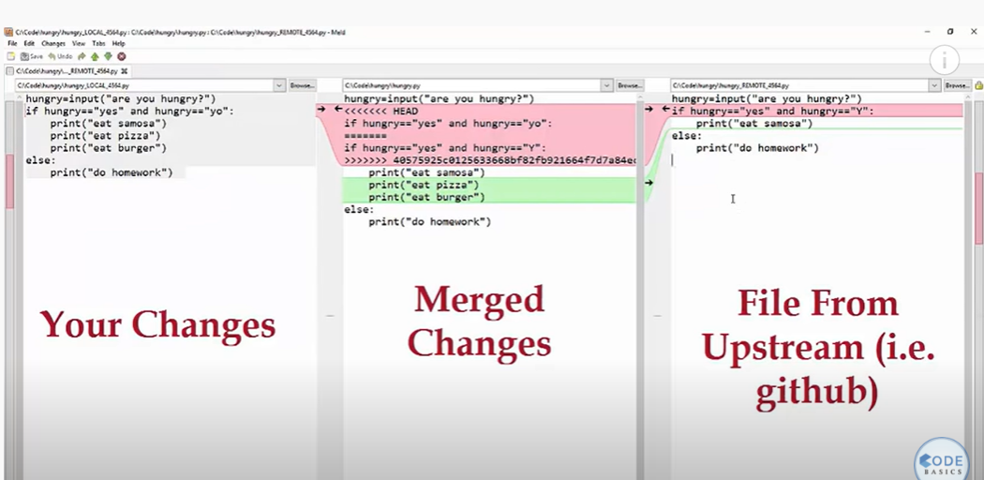

Close them without saving

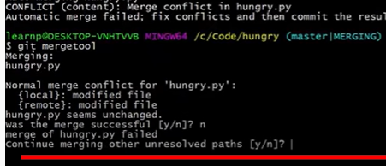

N

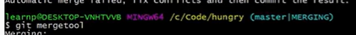

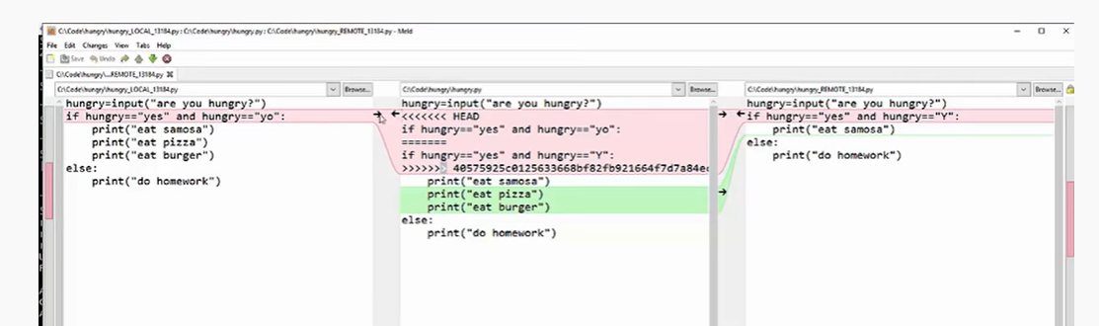

Click on arrow which u wanted to keep

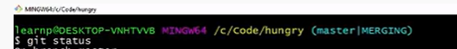

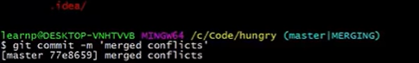

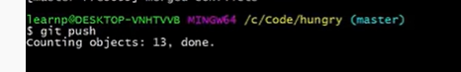

**Git Github Tutorial 10: What is Pull Request?**

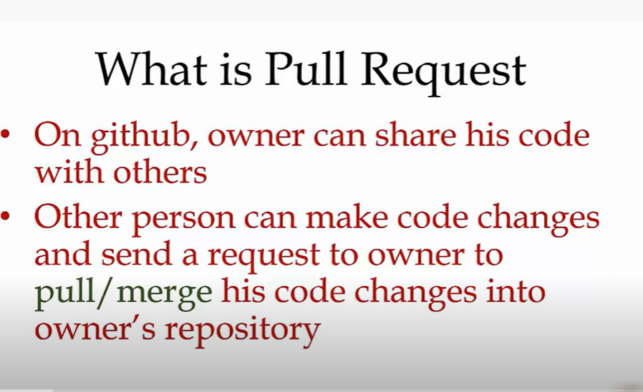

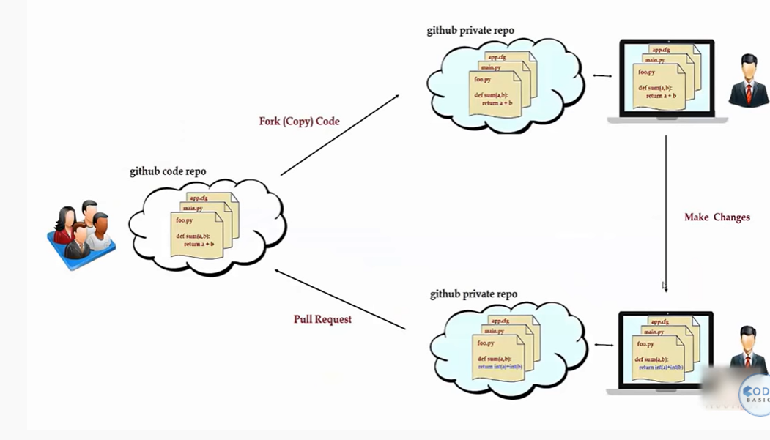

She can login

And fork the code of other people into our account

Change code

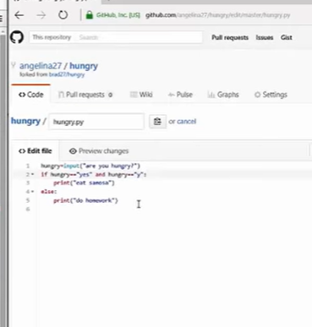

Commit changes

Now create pull request

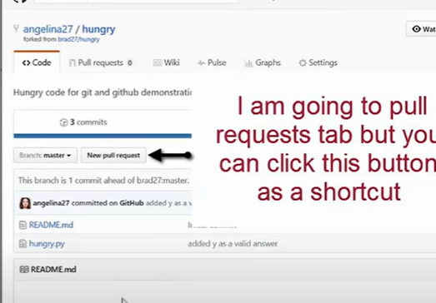

Pull request

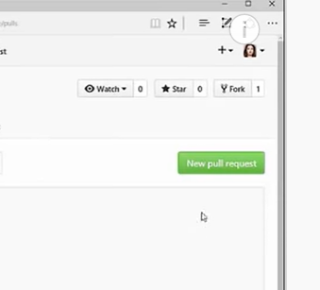

Which repository

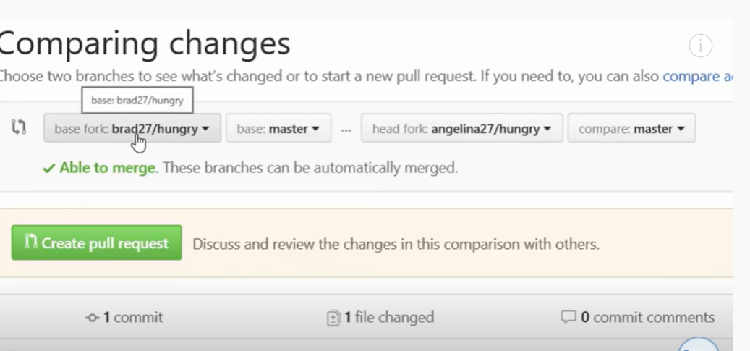

Angelina27/hungry repo to brad27/hungry repository

Create full request

Meaningful command

Now in brad acc

We see notification

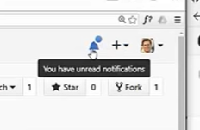

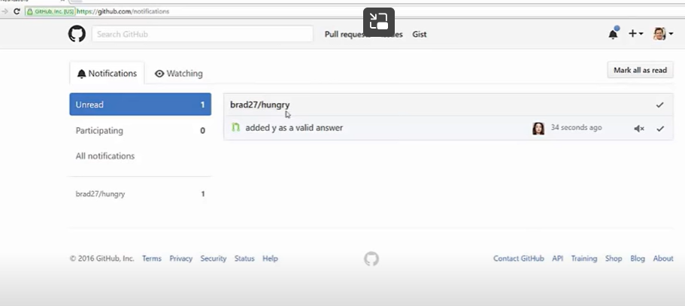

**Git And Github Series- Introduction, Installation Of Git And Understanding Basic Commands**

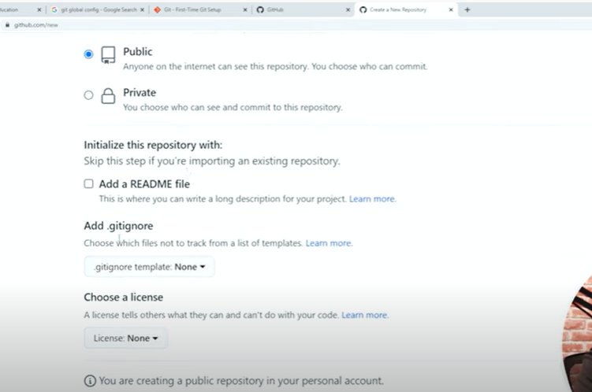

Git cli

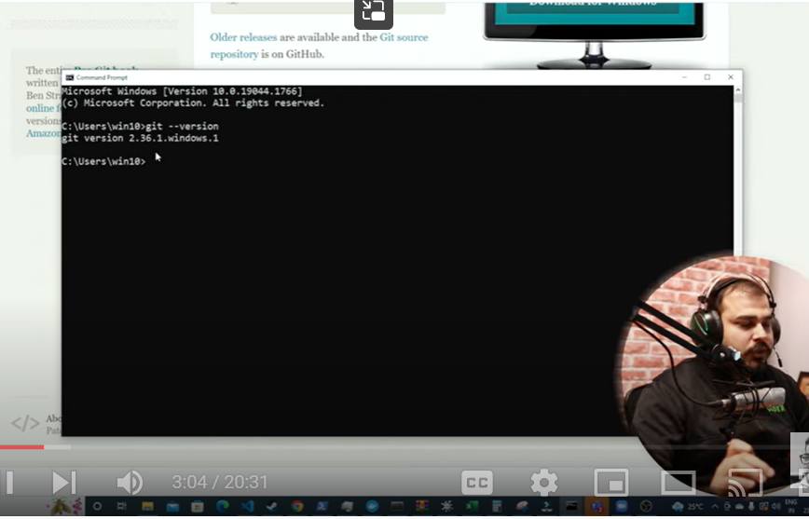

Create files – push

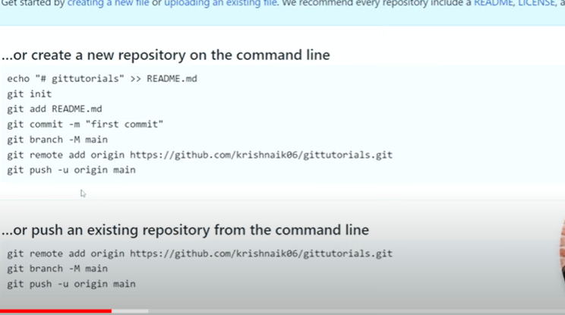

Cd path where our files

‘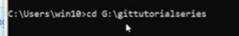

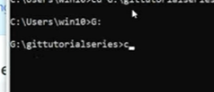

Clear

Initialize git repo

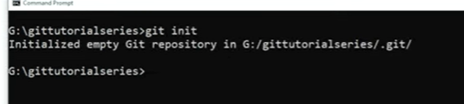

dir

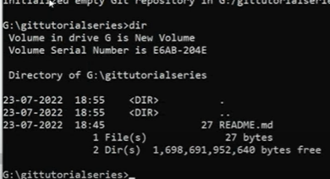

It creates .git when u initialize repo

.git not required to push

---------------global configuration--------

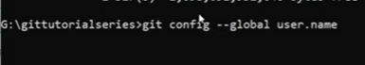

If ur name comes we are already configured

Otherwise

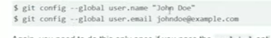

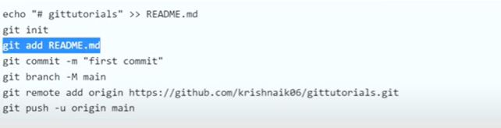

Created readme file already in local file

Now GIT add

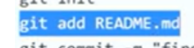

Git status

If it shows untracked file

Git add readme.md

Now it is tracked – in staging environment



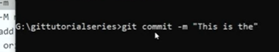

Git branch

Master

Rename master branch – to main branch

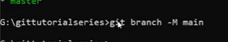

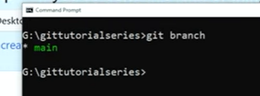

Which origin / repo we need to add file



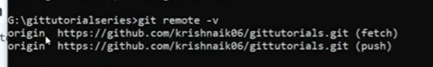

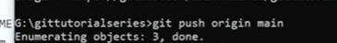

When I created new file in local computer and made changed in old file

When pushin both

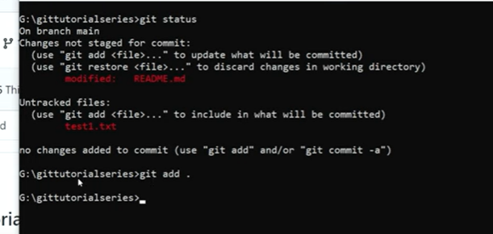

Git add .

Git status

Git commit

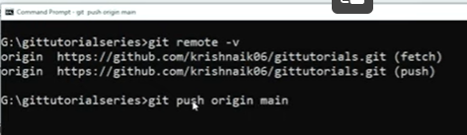

How to clone git repo to local system

Create a new folder

Give folder location in gitbash

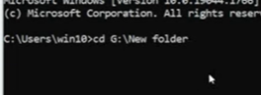

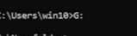

Now to clone entire repository

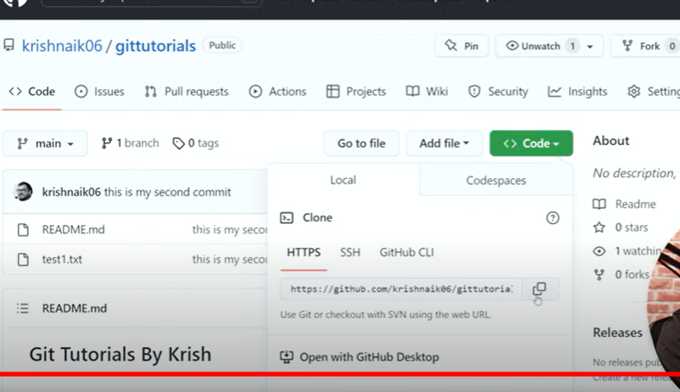

Copy url in git

